**How to get the Frequencies of the VCO with the parametric sweep**

1. Run the Parametric Sweep (ADE Window 🡪 Tools 🡪 Parametric Sweep)

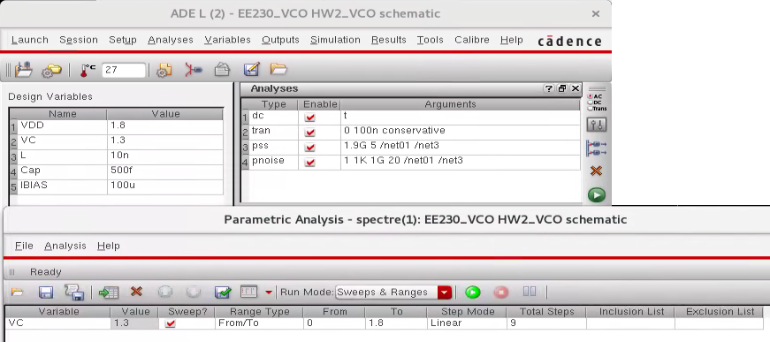

1. After simulations, select the whole “Family” of waveforms & send to calculator.

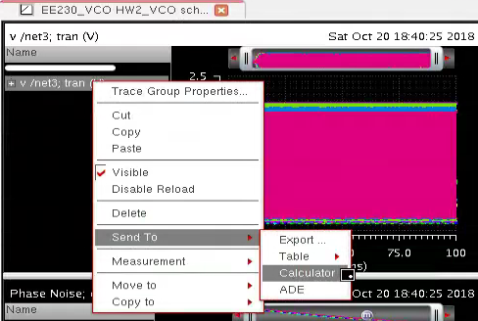

1. Use the “Clip” function to select the region in which the VCO’s output is stable.

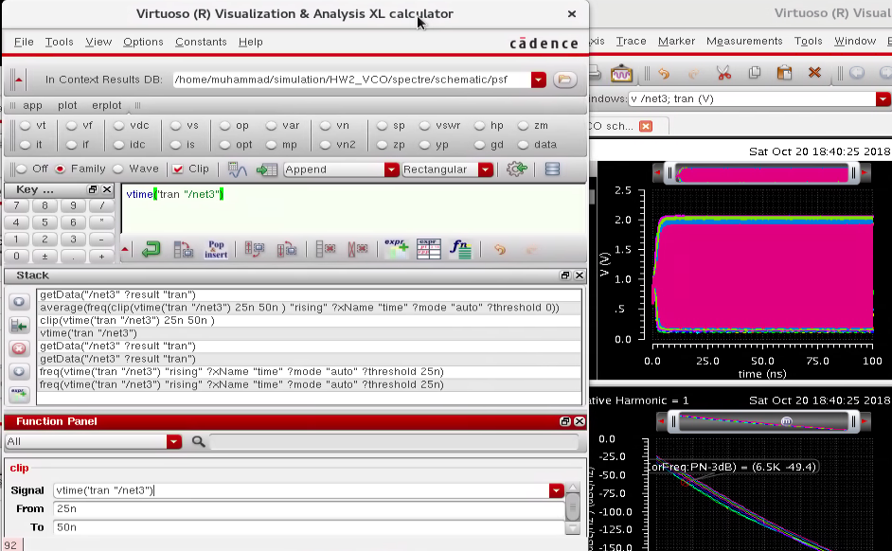

1. Use the “freq” function to get the frequency Vs time in that region, & “average” function to get the average value (a single value) for the frequency.  
   
2. Plot to get the frequency Vs the swept variable

